

**MATHEMATICS DEPARTMENT**

**Year 12 MATHEMATICS SPECIALIST**

DATE: 4th December 2015 Name__________________________

**Reading Time:** 3 minutes

**SECTION ONE: CALCULATOR FREE**

TOTAL: 27 marks

EQUIPMENT: Pens, pencils, pencil sharpener, highlighter, eraser, ruler, SCSA formula sheet.

WORKING TIME: 25 minutes (maximum)

**SECTION TWO: CALCULATOR ASSUMED**

TOTAL: 25 marks

EQUIPMENT: Pens, pencils, pencil sharpener, highlighter, eraser, ruler, drawing instruments, templates, up to 3 Calculators,

1 A4 page of notes (one side only), SCSA formula sheet.

WORKING TIME: 20 minutes (minimum)

|  |  |  |  |  |  |
| --- | --- | --- | --- | --- | --- |
| **SECTION 1**  **Question** | **Marks available** | **Marks awarded** | **SECTION 2**  **Question** | **Marks available** | **Marks awarded** |
| **1** | **6** |  | **5** | **7** |  |
| **2** | **6** |  | **6** | **4** |  |
| **3** | **10** |  | **7** | **7** |  |
| **4** | **5** |  | **8** | **7** |  |
|  |  |  |  |  |  |
| **Total** | **27** |  |  | **25** |  |

Section One: Calculator-free [27 marks]

This section has Four (4) questions. Answer all questions. Write your answers in the spaces provided

Question 1 [6 marks]

Simplify each of the following expressions, writing your answer in exact polar form.

(a) 



✓Applies de Moivre’s theorem

✓ change to polar form

[2]

(b) 



✓Applies de Moivre’s theorem

✓Simplifies answer

[2]

(c) 



✓Applys de Moivre’s theorem

✓Able to manipulate index

[2]

Question 2 [6 marks]

(a) (i) Find the quotient and the remainder for , hence rewrite  in the form  [3]



✓ Divides to find H(z)

✓ Finds the remainder is 2z



✓ rewrites the expression correctly

(ii) Hence, solve  [3]



✓✓ solves for the other two solutions

✓ solves for z = 1

**Question 3 [10 marks]**

Given the graph of is given as follows;

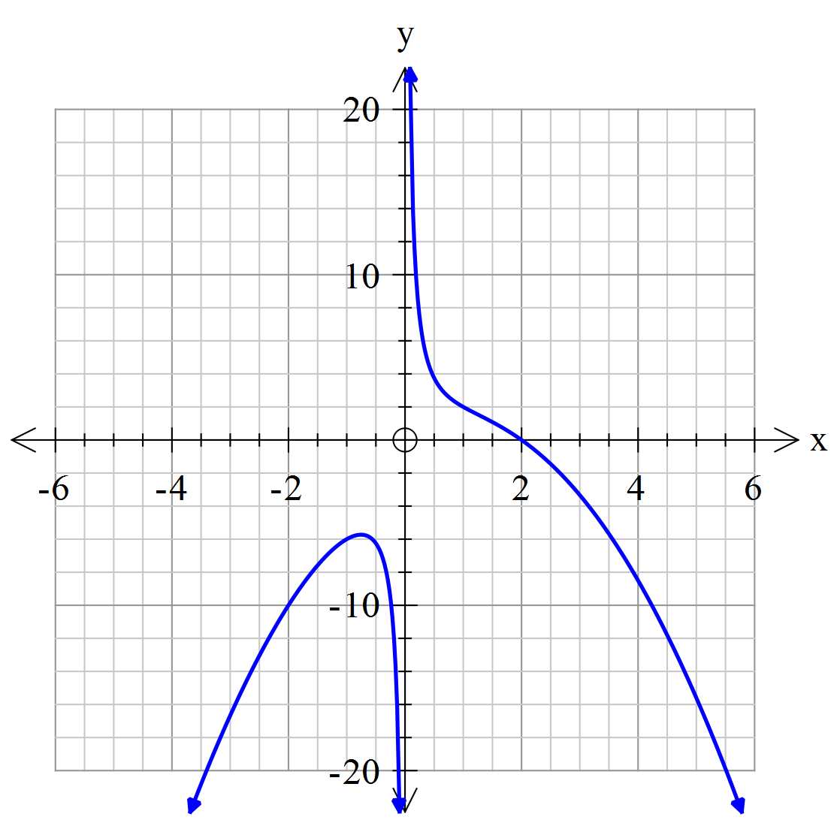

Sketch the graph of

(a) (i) 

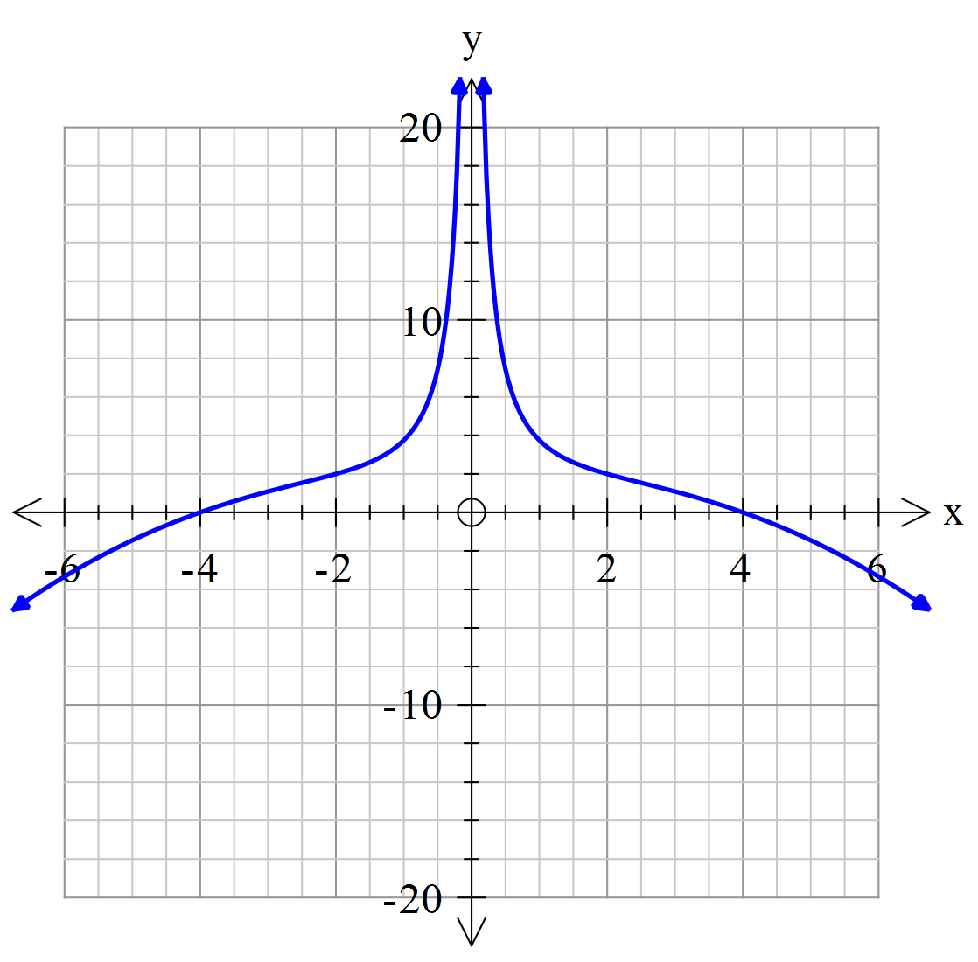

✓ removes the graph x<0

✓ mirrors the graph x>0 over the y-axis

✓ dilates the graph by a scale factor of 2 along the x-axis

[3]

(ii) Sketch the graph of . [3]

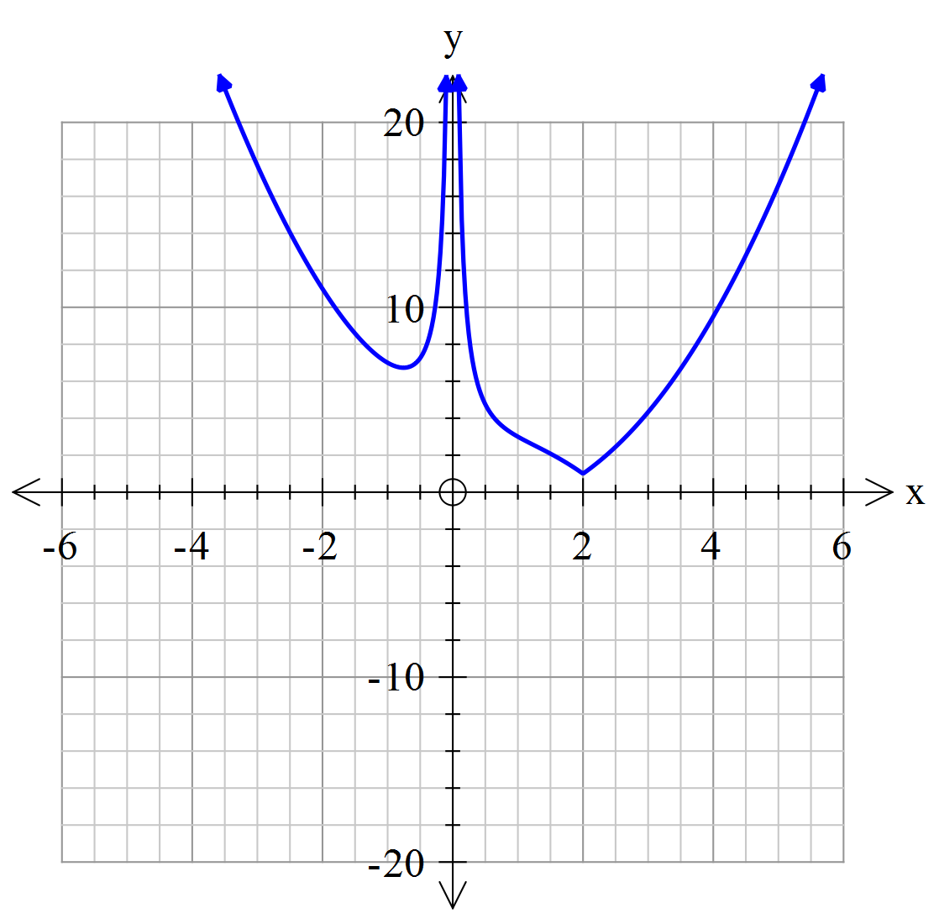

✓ reflects the part of the graph y<0 over the x-axis for x>0

✓ reflects the part of the graph y<0 over the x-axis for x<0

✓ translates the graph 1 unit up

(b) Given that and , find the domain and range of the composite function  [4]

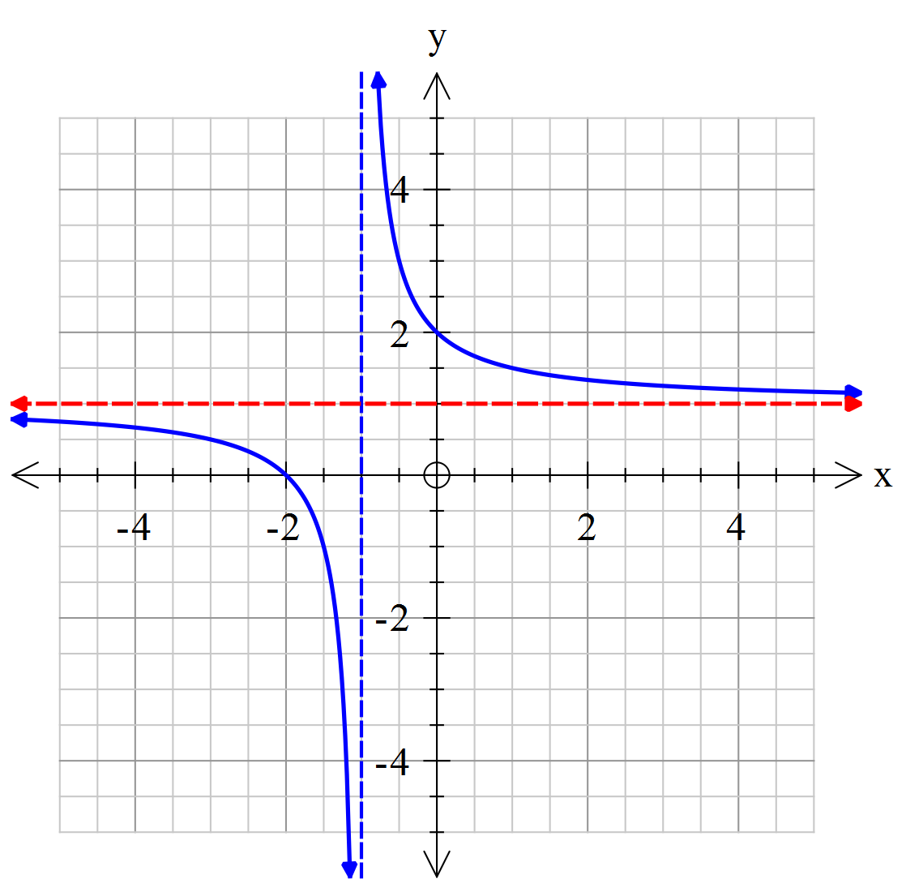 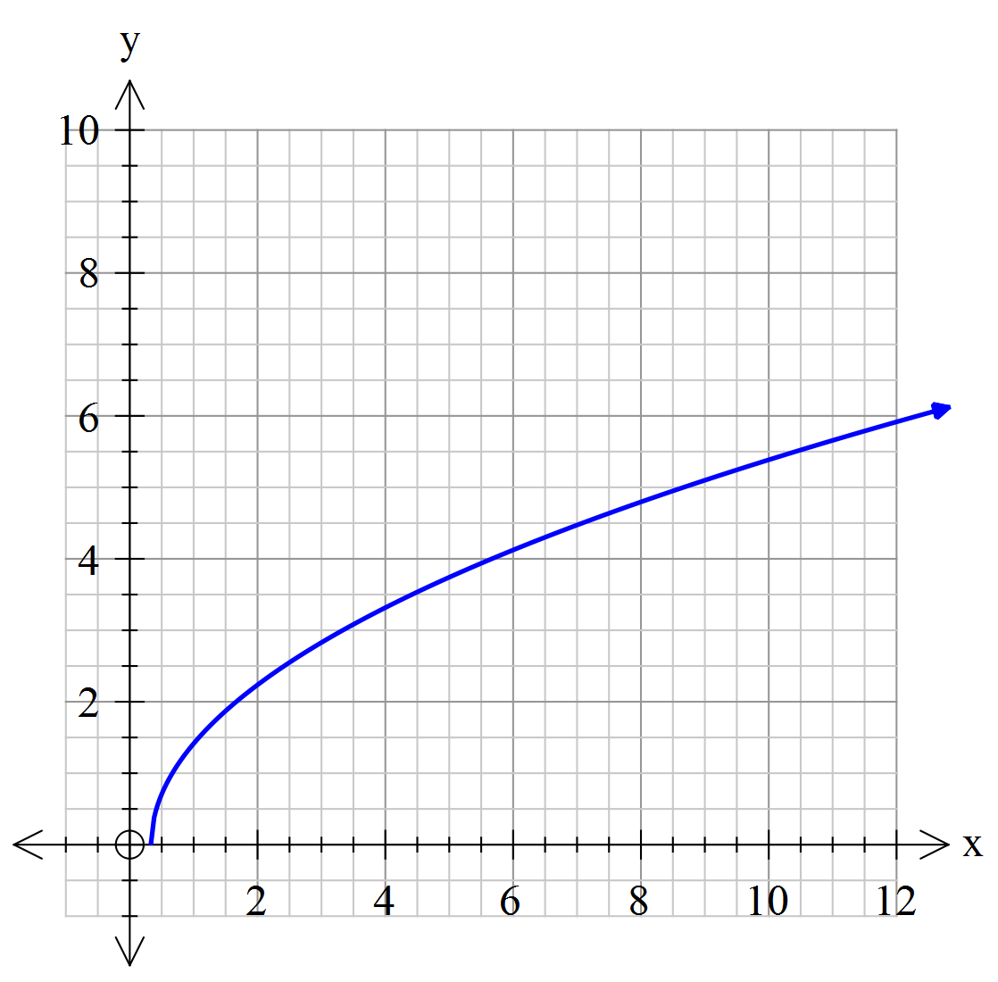

Domain Range







✓ ✓ Both domain restrictions (1 mark each)

✓✓ Both range restrictions (1 mark each)



Question 4 [5 marks]

(a) On an Argand diagram sketch the loci of points and that satisfy the following condition;



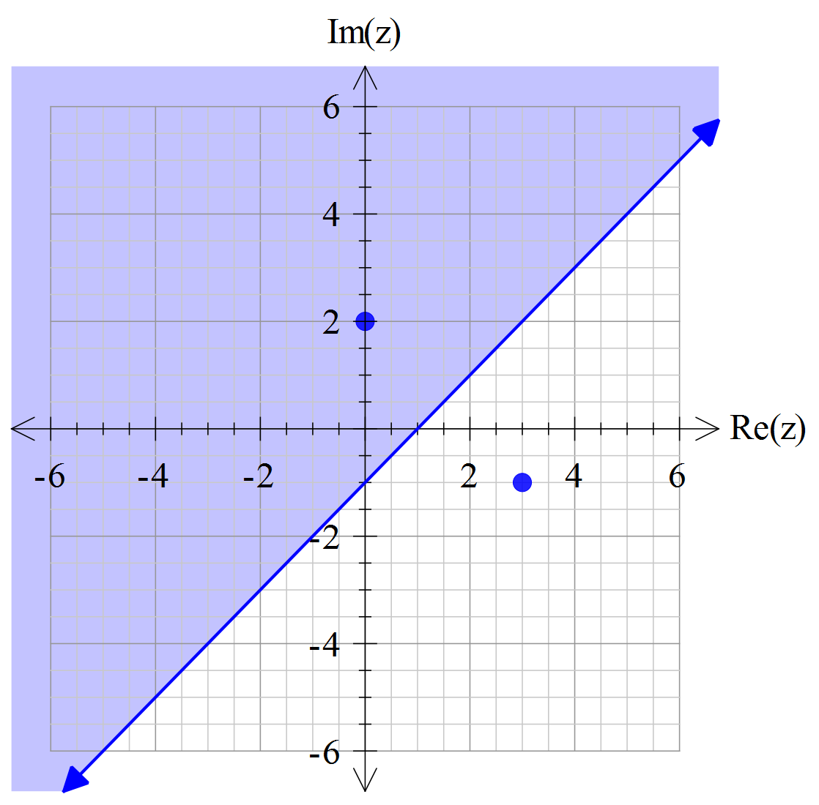 [3]

✓ Graphs two points

✓Draws a line through the midpoint, perpendicular

✓Shades above the line

(b) Give the equation of the locus in Cartesian form.



✓ Sets up Cartesian equation simplified

✓Simplifies with correct inequality

[2]

NAME:_______________________________________

**Section Two: Calculator-assumed [25 marks]**

This section has four (4) questions. Answer all questions. Write your answers in the spaces provided

Question 5 [7 marks]

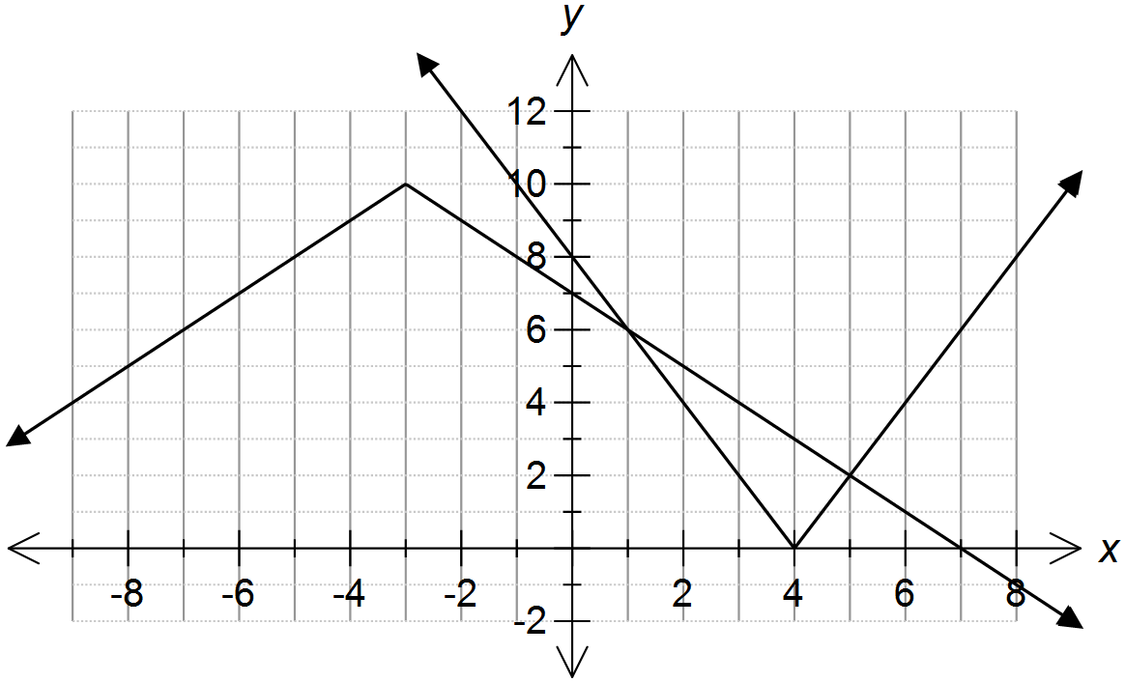

(a) Use the diagram above to solve for x in the following.

(i) 

[1]

✓ Both x values given



(ii) 

✓ Correct x –values

✓ Correct domain

[2]



(b) Solve the following algebraically  [4]

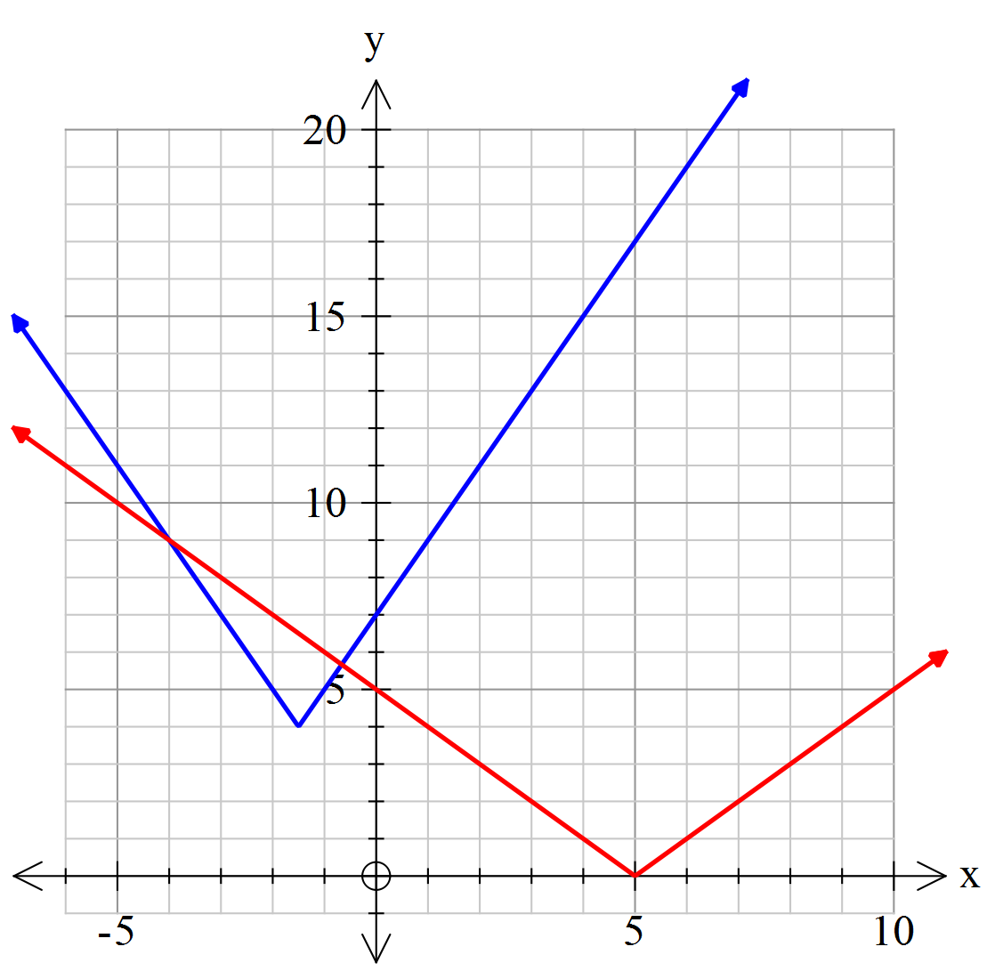

✓ Draws a graph and identifies the critical points of x=-1.5 and x=5

✓ Finds the correct linear equations of each relevant function

✓ Solves for the 2 intersections

✓ Writes the inequality correctly



Question 6 [4 marks]

Given the position of *z* and *w* on the Argand diagram below. Label the points A, B, C and D using the following options.

      

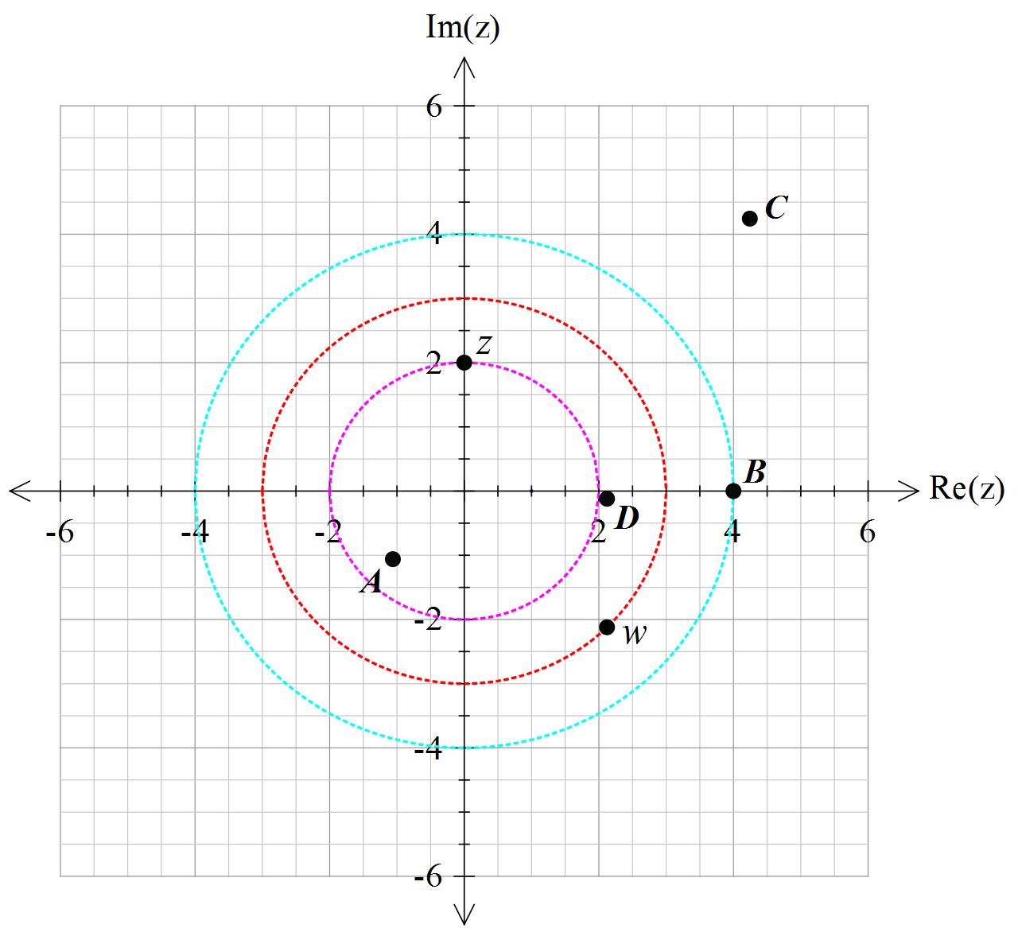



A [1]



B [1]

✓✓ ✓ ✓ 1 mark each correct answer



C [1]



D [1]

Question 7 [7 marks]

(a) Represent on the Argand diagram provided below, the loci of points, that satisfy the following conditions;

 ,  and 

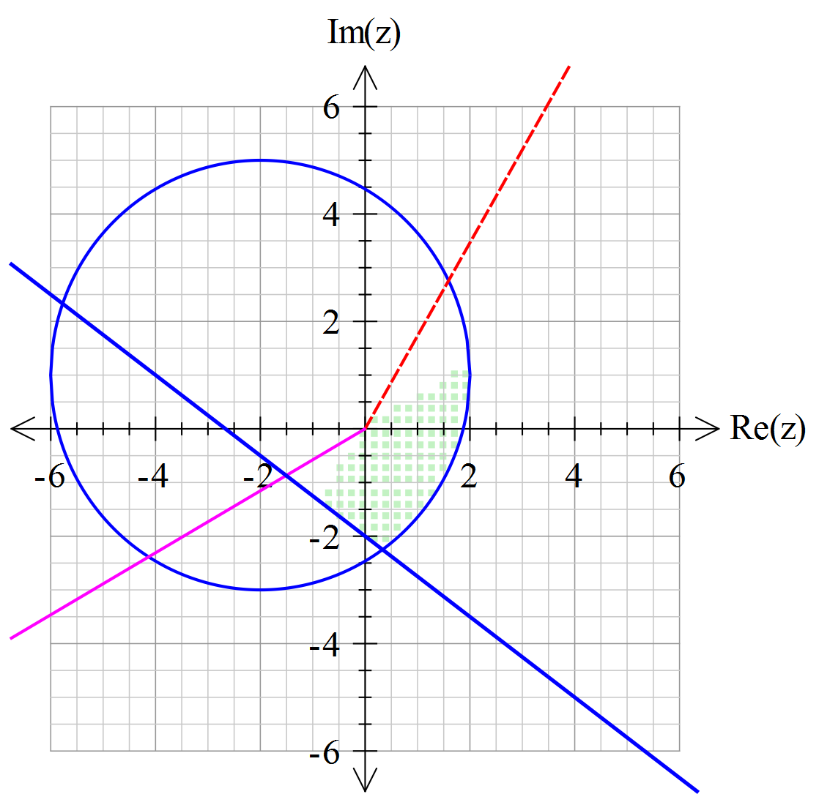

✓Circle drawn correctly

✓ Arg drawn correctly

✓ Line drawn correctly

✓ Shades correctly

[4]

(b) Given that  state the minimum and maximum value of .



✓Finds radius

✓ States min correctly

✓ States max correctly

[3]

Question 8 [7 marks]

1. Using your CAS calculator (or otherwise) find all the solutions to  in exact polar form, where   and . [4]



✓Changes to polar form

✓ applies De Moivre’s theorem and gives first solution

✓ Identifies they need to add 2PI/5

✓ Gives other 3 solutions

1. Draw the solutions from (a) on the complex plane below. Show all major features.

[3]

✓ Correct placement and magnitude of first point z

✓All other points magnitude of 4

✓ Other solutions are distributed evenly 2PI/5 angle apart

